**The Galleon trial**

Network effects

**A massive insider-trading trial shakes Wall Street**

Mar 10th 2011 | *New York* | from the print edition

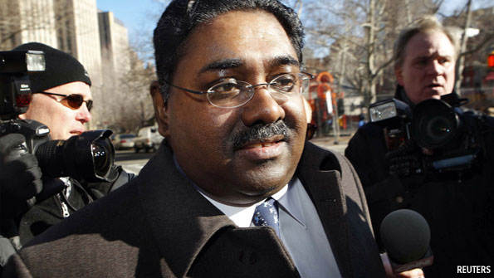Last days of the Raj?

“RAJ RAJARATNAM is not a master of the universe, but rather a master of the Rolodex.” That is how Robert Khuzami, director of enforcement at the Securities and Exchange Commission (SEC), described the hedge-fund titan in October 2009 when he was arrested for insider trading. Mr Rajaratnam used to be considered one of Wall Street’s cleverest investors. His hedge fund, Galleon Group, once managed $6.5 billion. But on March 9th, when the humbled Mr Rajaratnam showed up for the start of his trial, he didn’t look much like a master of anything, save his six-person defence team.

Mr Rajaratnam is at the centre of one of the largest insider-trading cases in history. Government prosecutors allege that Mr Rajaratnam used his wide network of contacts, including executives at big companies like IBM and Intel, to track down non-public information which he then used for trades, raking in profits worth $45m. Many of his erstwhile friends and associates have already confessed to wrongdoing. Of the 26 people that the US Attorney’s office has charged in connection with Galleon, 19 have pleaded guilty. Mr Rajaratnam insists he is innocent and traded only on the basis of public information.

The trial is expected to last ten weeks and could feature as many as 102 witnesses, including some of Wall Street’s top brass. Lloyd Blankfein, the boss of Goldman Sachs, and David Viniar, the bank’s chief financial officer, may testify. Rajat Gupta, a former boss of McKinsey whom the SEC charged on March 1st with providing tips to Mr Rajaratnam, may be summoned, too. It is not clear yet whether Mr Rajaratnam himself will take the stand. Federal prosecutors will play recordings of phone conversations during the trial, so his voice will be heard regardless.

A jury of 12 people will decide the fate of Mr Rajaratnam, who could spend up to 20 years in jail if he is convicted, according to some estimates. Given these high stakes, it is no surprise that selecting the dozen jurors was a painstaking process. Mr Rajaratnam’s lawyers expressed concern that the SEC’s charges against Mr Gupta could bias a jury. There is also the public’s resentment of Wall Street. Richard Holwell, the judge trying the case, asked prospective jurors more than 50 questions to gauge their eligibility, including whether they were strongly biased against wealthy financiers who do million-dollar transactions. Two said they were, and were dismissed.

Mr Rajaratnam is not the only one who has a lot riding on the outcome of this case. After its failure to spot Bernie Madoff’s Ponzi scheme, the SEC is under pressure to prove it has got tougher on rogue hedge funds. The Galleon affair may be about insider dealing but the government has adopted heavy-duty crime-fighting tactics including wiretapping and raids. If Mr Rajaratnam is acquitted, it will be a huge embarrassment for prosecutors.

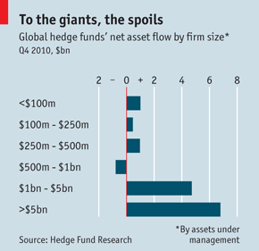

Others are also on edge. When the SEC first brought charges in the Galleon affair, Preet Bharara, the US attorney for the Southern District of New York, who is the lead prosecutor in Mr Rajaratnam’s trial, said it should be a “wake-up call for Wall Street”. Mr Bharara meant what he said. The SEC has been paying close attention to the use of “expert network” firms, which connect traders who want to know about a certain company or industry with consultants who can tell them about it. The firms are supposed to provide only details that are public, or can be found out legally (“market colour” is what people in the industry call it). But the SEC has raised concerns that employees at expert networks are going too far and sharing material, non-public information with those willing to pay for it.

Last November the agency charged a French doctor for allegedly tipping off a trader at a hedge fund about a death in a clinical drug trial. The doctor is thought to have served as a consultant at an expert network. Then, last month, the SEC charged ten people who were employees or clients of Primary Global, an expert network, with insider trading. Dozens of subpoenas have reportedly been sent out to other hedge funds, mutual funds, banks and expert networks to gather more information. More charges may soon follow.

The effect on parts of the hedge-fund industry has been chilling. So far this year at least three funds have announced plans to close down because of charges or raids by government officials, including Barai Capital Management (charged), Level Global (raided) and Loch Capital (raided). Level Global and Loch saw investors redeem money as soon as possible because of the raid, even though they haven’t been charged with any wrongdoing. “It’s McCarthyism,” says the boss of one hedge fund. “You’re dead if you’re accused. You’re guilty unless proven innocent. It’s really scary. It’s destroying businesses.”

Most fund managers prefer to bite their tongues. They are trying to spruce up their policies to avoid the government’s wrath and reassure their anxious investors. Some have suspended dealings with expert-network firms entirely, until the SEC clarifies its views on using them.

Many are putting more money toward beefing up their compliance departments, and setting out clear rules for when traders are allowed to talk to consultants. “Hedge funds are going to need to have the same quality of compliance officers that banks have,” says Stephen Bainbridge, a professor at University of California, Los Angeles, School of Law. One hedge-fund executive thinks that some funds will move to operating a single trading book, rather than multiple books, in order to have more oversight over individual traders for whose actions they are liable.

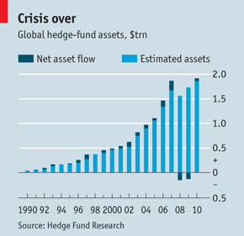

All of which makes an already difficult fund-raising environment for small funds even rougher. Investors want to make sure that managers have clear compliance policies in place. That favours larger funds, which can afford the extra safeguards. The industry’s assets under management are now back above pre-crisis levels (see chart). But of the more than $13.9 billion that investors put into hedge funds during the fourth quarter, 83% went to funds with more than $1 billion under management.

Even the largest funds are not safe from government scrutiny, however. Rumours abound that the SEC is trying to target one of the industry’s largest funds. And Mr Rajaratnam himself can attest that having billions of dollars under management does not keep you out of court.